**Steps to run Platform App:**

1. git clone [git@github.com:nisum-inc/IMP.git](mailto:git@github.com:nisum-inc/IMP.git)
2. cd platform-web
3. npm install
4. npm start

**Node server is up at** <http://localhost:8080/api/v1/campaign/2>

This will ask for key.

Open <http://localhost:8080/signin>

This will return a key.This token to be send with all api calls with name **api_key** or asheader **x-access-key**

**Steps to run API Service (Swagger) :**

1. From IMP root $> cd API
2. npm install
3. npm start (If any issue check swagger is installed correctly) or run **swagger project start**

**Api service is up at** <http://localhost:9999/>

Steps to check with swagger tool :

1. Open **IMP\docs\ui\index.html** in browser
2. Add the key .
3. Click the default link

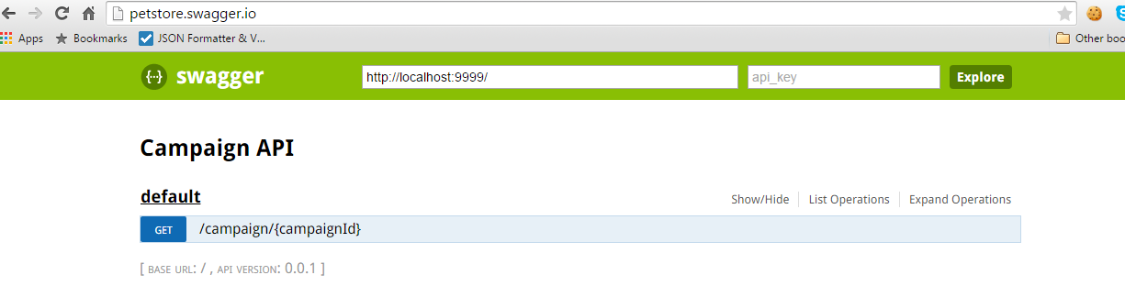

1. Click the link /campaign/{campaignId}

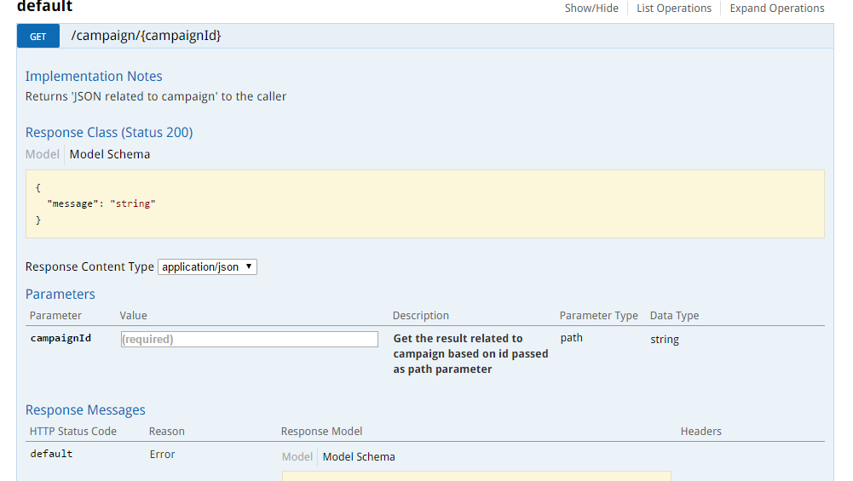

1. Give campaign id and click Try it out button we can see the response ,which is mock data set in node controller.
2. To run API test $> npm test